# ANDROID ASSISTANT FOR BLIND AND BLLIND TRACKER

A PROJECT REPORT

Submitted by

**APARNA V**

**CUAWMCS003**

In Partial Fulfillment of the Requirements for the Degree of

**MSc. COMPUTER SCIENCE**



**CENTRE FOR COMPUTER SCIENCE AND INFORMATION TECHNOLOGY (CCSIT)**

**UNIVERSITY OF CALICUT**

**JUNE 2024**

## ACKNOWLEDGEMENT

Let me take this opportunity to thank all those who have been directly and indirectly involved in making this project a success. First of all, thank you Universe for making this possible.

I express my gratitude to **Mrs. Seema S**, Associate Coordinator, Centre for Computer Science and Information Technology, University of Calicut .

I am extremely grateful to **Mrs. Teena G Nath**, Assistant Professor, Centre for Computer Science and Information Technology, University of Calicut, my Project-in-Charge for the encouragement, valuable suggestions and guidance rendered.

I express my sincere thanks to my family and friends who helped me in overcoming all the hurdles thus gearing me towards the fulfillment of the task that I had overtaken.

I also express my profound gratitude to all others who, in some way or another, helped me with this project till the end.

Place: **CU CAMPUS**

Date**: 25/06/2024**

### APARNA V

**CUAWMCS003**





## DECLARATION

I **APARNA V,** hereby declare that the project work entitled **“ANDROID ASSISTANT FOR BLIND AND BLIND TRACKER”** is original work done by me, under the guidance of **Mrs. Teena G Nath,** Assistant Professor**,** Centre for Computer Science and Information Technology, University of Calicut. This project report is submitted in partial fulfillment of the requirement for the award of the degree of **M.Sc.** **Computer Science** during the period of study at University of Calicut.

Place: **CU CAMPUS**

Date:**25/06/2024**

### APARNA V

**CUAWMCS003**



## CERTIFICATE

*Certified that this is a bonafide record of the project work entitled* **“ANDROID ASSISTANT FOR BLIND AND BLLIND TRACKER”** *submitted by* **APARNA V (Reg No: CUAWMCS003)** *in partial fulfillment of the requirement for the award of the degree of* **MSc. COMPUTER SCIENCE** *from University of Calicut.*

### Mrs. TEENA G NATH

Assistant Professor CCSIT, CU Campus

**Place:** CU CAMPUS

**Date :25/06/2024**

### Mrs. SEEMA S

Associate Coordinator CCSIT, CU Campus

**PROJECT EVALUATION REPOERT OF THE EXAMINERS**

Certified that the candidate was examined by us in the Project Viva Voice Examination held on …..……………......................................................... and her Register Number is

…………………………………………………………………………………………… …….

### Examiners

……………………………….

……………………………….

Date**: 25/06/2024**

### APARNA V

**CUAWMCS003**



# ANDROID ASSISTANT FOR BLIND AND BLLIND TRACKER





## ABSTRACT

Navigating the world independently poses significant challenges for individuals with visual impairments. While the white cane has been a staple tool for mobility, it falls short in comprehensive obstacle detection and ensuring safety.This paper proposes a novel solution aimed at empowering blind individuals with autonomous and emergency assistance capabilities. Our proposed system leverages Android technology to develop an intelligent assistant and tracker tailored specifically for the blind . Through a combination of sensor integration, GPS tracking, and communication functionalities, our system enables blind users to navigate unfamiliar environments without relying on external assistance. Furthermore , in the event of getting lost or encountering emergencies, the system facilitates seamless communication with predefined contacts, ensuring prompt assistance and enhancing overall safety. This paper presents the design, implementation, and evaluation of our Android-based solution, highlighting its potential to significantly improve the mobility and independence of blind individuals while enhancing their safety and security.

**INDEX**

|  |  |
| --- | --- |
| **CONTENTS** | **PAGE NO.** |
| **1. INTRODUCTION** | 1 |
| * INTRODUCTION | 2 |
| **2. SYSTEM STUDY** | 3 |
| * EXISTING SYSTEM | 4 |
| * PROPOSED SYSTEM | 4 |
| **3. SYSTEM ANALYSIS** | 5 |
| * PRELIMINARY INVESTIGATION | 6 |
| * FEASIBILITY STUDY | 6 |
| **4. SYSTEM SPECIFICATION** | 8 |
| * HARDWARE SPECIFICATION | 9 |
| * SOFTWARE SPECIFICATION | 10 |
| * MODULES | 11 |
| **5. SYSTEM DESIGN** | 13 |
| * INPUT DESIGN | 14 |
| * OUTPUT DESIGN | 15 |
| * DATA FLOW DIAGRAM | 15 |
| * DATABASE DESIGN | 22 |
| **6. SYSTEM DEVELOPMENT** | 29 |
| * BRIEF DESCRIPTION ABOUT THE TOOLS/SCRIPTS FOR IMPLEMENTATION | 30 |
| * MODULE HIERARCHY | 33 |
| * SOURCE CODE | 34 |
| * PROBLEMS ENCOUNTERED | 37 |
| **7.SYSTEM TESTING AND IMPLEMENTATION** | 38 |
| * SYSTEM TESTING | 38 |
| * SYSTEM IMPLEMENTATION | 41 |
| **8. SYSTEM MAINTENANCE** | 44 |
| * SYSTEM MAINTENANCE | 45 |
| **9. CONCLUSION** | 46 |
| * CONCLUSION | 47 |
| * SCOPE FOR FUTURE ENHANCEMENT | 48 |
| **10. BIBLIOGRAPHY** | 49 |
| * BIBLIOGRAPHY | 50 |
| **11. APPENDIX** | 51 |
| * SCREENSHOTS | 52 |



**LIST OF FIGURES**

|  |  |  |
| --- | --- | --- |
| **SL NO.** | **FIGURES** | **PAGE NO.** |
| 1 | Figure 1 (Level 0 Diagram) | 17 |
| 2 | Figure 2 (Level 1 Diagram) | 18 |
| 3 | Figure 3 (Level 2Diagram) | 19 |
| 4 | Figure 4 (Level 2.1 Diagram) | 20 |
| 5 | Figure 5 (Level 3 Diagram) | 21 |



**LIST OF TABLES**

|  |  |  |
| --- | --- | --- |
| **SL NO.** | **TABLES** | **PAGE NO.** |
| 1 | Table 1 (login) | 24 |
| 2 | Table 2 (companion) | 24 |
| 3 | Table 3 (Blind person) | 25 |
| 4 | Table 4 (Familiar prson) | 25 |
| 5 | Table 5 (complaints) | 26 |
| 6 | Table 6 (Feedback and rating) | 26 |
| 7 | Table 7 (Emergency call) | 27 |
| 8 | Table 8(Location) | 27 |
| 9 | Table 9 (Message) | 28 |





## INTRODUCTION



**INTRODUCTION**

Blind mobility is one of the main brainstorming challenges that scientists are still facing around

different parts of the world and still researching to implement suitable blind assistive devices. In

recent years blind mobility has become an important issue since a large number of people are

visually impaired and partially sighted. Navigating a blind person is a great challenge as blind

person has to rely on other. The simplest and most widely used travelling aid used by all blinds is

the white cane. It has provided those people with a better way to reach destination and detect

obstacles on ground, but it cannot give them a high guarantee to protect themselves from all level

of obstacles. Sometime it happens that blind people are lost and their guardians are in tension

about them. There has been many efforts but even now, it is not easy for the blind people to move

independently from one place to another. To solve this great problem we proposed a system , the

system where a blind person can move without the help of other and can make emergency call to a

predefined number and we can find out him/her easily if he/she is lost.



## 2.SYSTEM STUDY



**SYSTEM STUDY**

### EXISTING SYSTEM

Actually there is no specific application for blind person. SMS to speech mechanism, SOS are only

available for blind person. Braille support phones are very costly.

### PROPOSED SYSTEM

Proposed system is a combination of website cum android application. Blind communicates with the system using mobile application. Recognition processes are carried out using offloading

method.



## 3.SYSTEM ANALYSIS



**SYSTEM ANALYSIS**

### PRELIMINARY INVESTIGATION

The main aim of preliminary analysis is to identify the problem. First, need for the new or enhanced system is established. Only after the recognition of need, for the processed system done then further analysis is possible.

Once the initial investigation is done and the need for new or improved system is established, all possible alternate solutions are chalked out. All those systems are known as “candidate system”. All the candidate systems are then weighed and the best alternative of all those is selected as the solution system, which is termed as the “proposed system”. The proposed system is then evaluated of its feasibility. Feasibility for a system means whether it is practical and beneficial to build that system.

The system has been designed in such a way that it can be modified with very little effort when such a need arises in the future. The system has been found to work efficiently and effectively. The administrator controls the entry system. He can add new authorities and update the authorities.

### FEASIBILITY STUDY

The feasibility study is defined as the practical extent to which a project can be performed successfully. When the client approaches the organization for getting the desired product developed, it comes up with a rough idea about what all functions the software must perform and which all features are expected from the software. This feasibility study is focused on the goal of the organization. This study analyzes whether the software product can be practically materialized in terms of implementation, the contribution of the project to organization, cost constraints and as per values and objectives of the organization. It explores technical aspects of the project and product such as usability, maintainability, productivity and integration ability.



Three key considerations involved in the feasibility analysis are:

1. Technical feasibility
2. Economic feasibility
3. Operational feasibility

### TECHNICAL FEASIBILITY

Technical feasibility assesses the current resources (includes the hardware and software) and technology. Its center on the existing computer system and to what extent it can support the proposed addition. Since the minimum requirements of the system like internet connection, a web server in the server system is met by an average user.

### ECONOMICAL FEASIBILITY

The economic analysis is to determine the benefits and savings with the current system and the proposed system that are compared with costs. The system is economically feasible, as the organization possesses the hardware and software resources required for the functioning of the system. Any additional resources, if required, can also be easily acquired. The proposed system was developed with available resources. Since cost input for the software is almost nil the output of the software is always a profit. Hence Software is economically feasible.

### OPERATIONAL FEASIBILITY

Operational feasibility assesses the extent to which the required software system performs a series of steps to solve business problems and user requirements. This is the longest phase in the development life cycle of a system. So, operational feasibility should be given much importance. The users of the application don’t need thorough training on the system. It has a user-friendly interface.



## SYSTEM SPECIFICATION



**HARDWARE SPECIFICATION**

The selection of hardware is very important in the existence and proper working of any of the software. When selecting hardware, the size and capacity requirements are also important. The hardware must suit all application developments.

Processor : Pentium 4 or above

Hard disk : 80 GB and above

RAM : 4 GB and above

Monitor : SVGA color

Keyboard : 104 keys

Mouse : Optical/scroll mouse



## SOFTWARE SPECIFICATION

One of the most difficult tasks is selecting software. Once the system requirement is found out then we have to determine whether a particular software package fits for those system requirements. This section summarizes the application requirement.

Operating System : Windows 8 or above

Front End : Html, CSS, JavaScript, Bootstrap, XML

Back End : MySQL

IDE : Android Studio, PyCharm

Framework : Django, Flutter

Language : Python, Dart, Java

## 

## MODULES

### ADMIN

* Login
* View companion and accept or reject
* View Blind Persons
* View Familiar person
* View complaint and sent reply
* View feedback and rating

 **COMPANION**

* Registration
* Login
* Manage Blind person
* Manage Familiar person
* Send complaint and view reply
* Sent feedback and rating
* Emergency help (video call)
* Track location
* Text to voice (sending message)

**BLIND PERSON**

* Object detection using Yolo
* Dlib based face recognition system
* Send emergency help(video call)
* Familiar person identification
* Audio call
* Text to speech (OCR)
* Currency Recognition using CNN

## 

## 



## 

## 

## 5. SYSTEM DESIGN

**SYSTEM DESIGN**

The detailed design of the system selected in the study phase is accomplished in the design phase and the user-oriented performance specification is covered into a technical design specification. The principle activities performed by the design phase are general system design, input design and the design of the database.

### INPUT DESIGN

Input design is the process of converting the user-oriented input data is to make the automation is easy and free from errors. The design of handling input specifies how data are accepted for computer processing. Input design is art of overall system design that needs careful attention and if includes specifying the means by which actions are taken. A system user interacting through a work station must be able to tell the system whether to accept input produce a report or end processing.

The collection of input data is considered to be the most expensive part of the system design. Since the inputs have to be planned in such a manner so as to get the relevant information extreme care is taken to obtain the information if the data going into the system is incorrect then the processing and outputs will magnify these errors. Input design is a part of overall system design, which requires careful attention.

The major objective of the input design is to make the data entry easier, logical and error free. With this objective the screen for the system is developed. The input design requirement such user friendliness, consistent format and interactive dialogue boxes for giving the development of the project. The data entry operator needs to know the space allocated for each field, the field sequence, which must match with source document and the format in which the data is entered.

### OUTPUT DESIGN

A quality output is the one, which meets the requirements of the end user and presents the information early. In any system, the results of processing are given to the user through the output. In the output design it is determined how the information is to be displayed for immediate need.

Output design should improve the relationship of the system with user and help in decision making. The objective of the output design is to define the format of all printed documents and of the screens that will be produced by the system. The output has been designed as per the needs of the institution. The suggestions of the user are also taken into consideration while designing the layout and the fields that are to be included in the project.

Operations are required primarily to communicate about the results of the processing to the user and to the management. They also provide the hardcopy of these results for later consultations and rectification. In this system operations are of different from like messages, input boxes and reports. All recent reports can be generated by the system Menu will help the user to select the required outputs.

### DATA FLOW DIAGRAM

Data flow diagram is used is to define the flow of the system and the its resources such as information. As the name suggests DFD is a representation of the data flow within the system. It includes processes, data store and external interfaces to the system. External interfaces may be treated as external entities. DFD's can by explode to sub-processes. Any two entities data store must be connected to each other by some process. The process cannot be directly connected to each other. The following are the four major components of the DFD:

### Process

* **Data store**

### Data flow

* **External Entity**

It is also known as the bubble chart. It is a simple graphical formalism that can be used to represent a system in terms of the input data to system, various processing carried out in these data and output data generated by the system. The main reason why this DFD technique is so popular is probably because of facts that DFD is very simple formalism. It is simple to understand and use. A DFD model uses a very limited number of primitive symbols to represent the functions performed by a system and the data flow among these systems. Starting with a set of high-level functions that a system performance of DFD model in hierarchically it represents various sub functions. The data flow diagramming technique also follows a simple set of intuitive concepts and rules.

### Process

Process shows the work of the system. Each process has one or more data inputs and produce one or more data outputs. Process is represented by rounded rectangles, circles or ovals in DFD's. Each process has a unique name and number. This name and number appear inside the rectangle that represents the process in a DFD.

### Data store

Data store is a repository of data. Processes can enter data into or retrieve the data from data store. Each data has a unique name.

### Data flow

Data flow show the passage of data in the system and represented by lines joining system components. An arrow indicates the direction of flow and the line is labeled by name of the data flow.

### External Entity

External Entities are outside the system but they either supply input data into the system or use other system output. They are represented by rectangles. They are entities on which the designer has control. They may be any natural person, corporation, partnership, sole proprietorship, association, organization, company, government agency etc.



### DFDs

### LEVEL 0



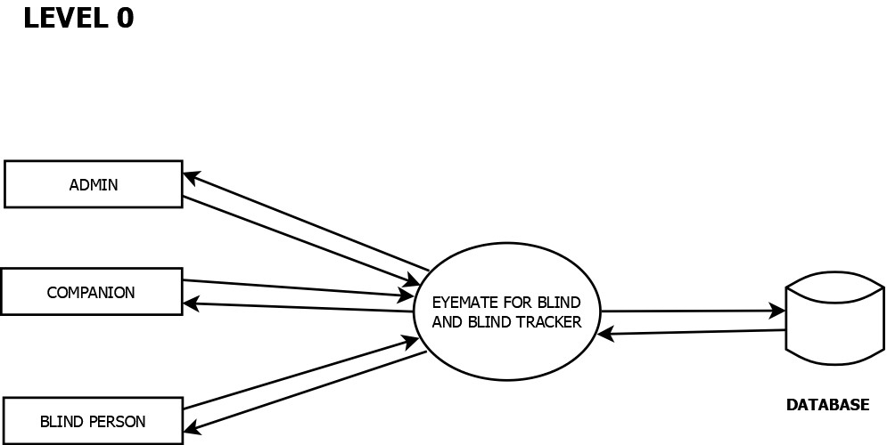

***Figure 1 (Level 0 Diagram)***



### LEVEL 1

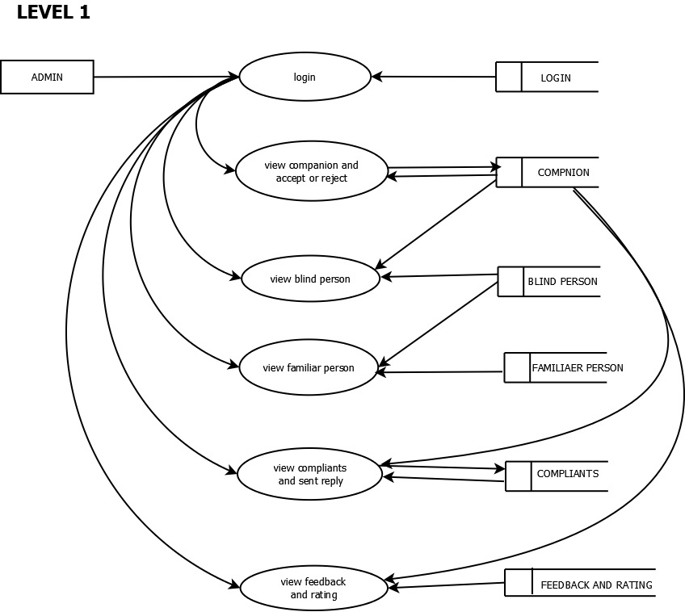

***Figure 2 (Level 1Diagram)***

**LEVEL 2**

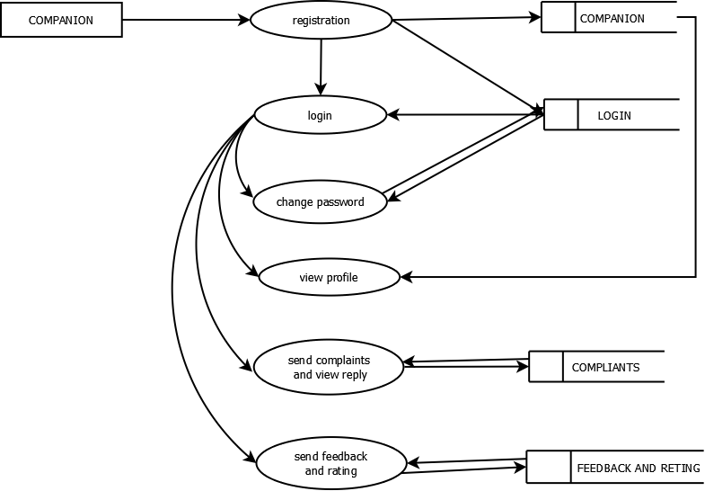



***Figure 3 (Level 2.1 Diagram)***



### LEVEL 2.1

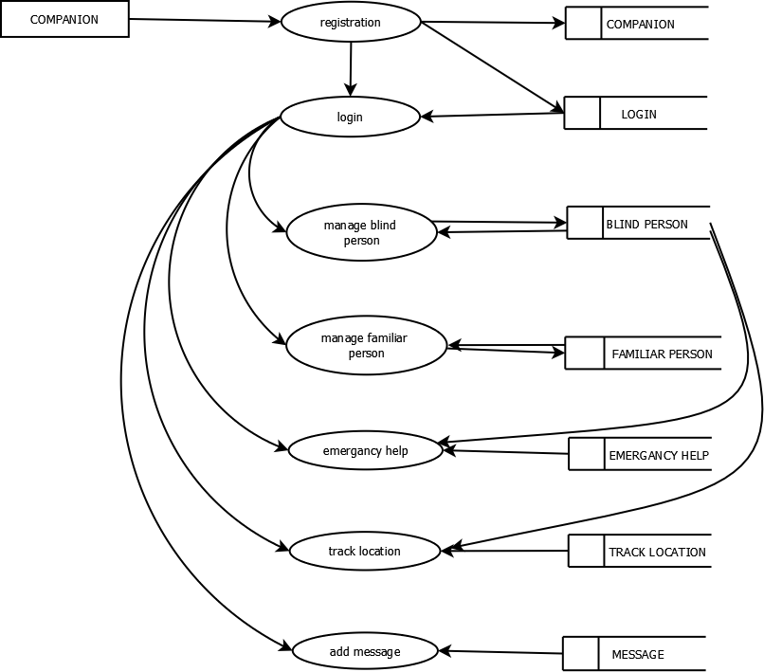

***Figure 4 (Level 2.2 Diagram)***

### 

### LEVEL 3

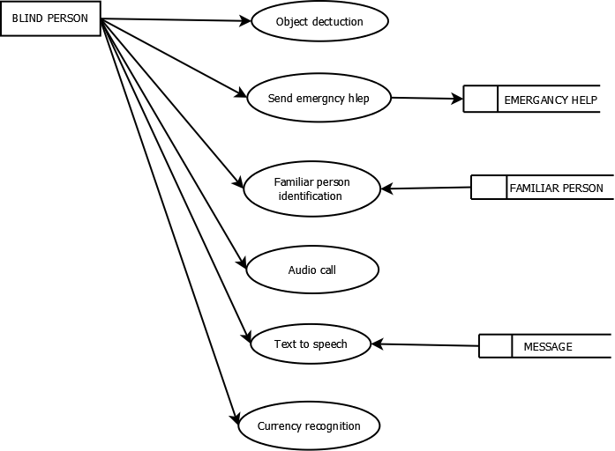

***Figure 4 (Level 3 Diagram)***

### DATABASE DESIGN

Database design is one of the most important parts of the system design phase. In a

database environment, common data are available and are used by several users. Instead of each program managing its own data, authorized users share data across the application with the database software managing the data as an entity. The primary objective of database design is fast response time to enquiries, more information at low cost, control of redundancy, clarity and ease of use, date and program independence, accuracy and integrity of the system, fast recovery and availability of powerful end-user languages. The theme behind a database is to handle information as an integrated whole, thus the main objective is to make the information as to access easy, quick, inexpensive and flexible for the users. Data directory specifies the major element in the system, and care should be taken while designing, in order to avoid unnecessary duplication of data. The entire package depends on, how the data are maintained in the system. Several tables are maintained in the system to store data that are required for the processing of various data as well as storing intermediate or final processed results.

Database design mainly aims at handling large volumes of information, involving the definitions for the structure of storage and provisions for the manipulation of information, providing safety of information despite system crashes due to unauthorized access.

Some conditions are satisfied in the database design stage:

* Control redundancy.
* Ease of use.
* Data independence.
* Accuracy and integrity.
* Recovery from failures.
* Security and privacy.
* Performance.

### NORMALISATION

It is a process of efficiency organizing data in database. Normalization has two main goals. One is to eliminating redundant data, ensuring data dependencies make sense. They reduce the amount of space a database consumes, and ensure that is logically stored.

### First normal form:

First normal form eliminates duplicate columns from the same table. It creates separate table for each group of related data and identify each row with a unique column or set of columns (primary key).

### Second normal form:

Second normal form meets all the requirements of the first normal form. It removes subset of data that apply to multiple rows of a table and place them in separate tables. Create relationship between these new tables and their predecessors through the use of foreign keys.

### Third normal form:

Third normal form meets all the requirements of the second normal form. It removes columns that are not dependent upon the primary key.

**TABLE**

Table 1 (Login)

### 

|  |  |  |  |
| --- | --- | --- | --- |
| **FIELD NAME** | **DATATYPE** | **LENGTH** | **CONSTRINTS** |
| L_id | int | 40 | Primar key |
| User name | vachar | 50 | Not null |
| Password | varchar | 50 | Not null |
| Type | varchar | 50 | Not null |

Table 2 (Companion)

|  |  |  |  |
| --- | --- | --- | --- |
| **FIELD NAME** | **DATATYPE** | **LENGTH** | **CONSTRAINTS** |
| companion_id | int | 25 | Primary key |
| Name | varchar | 50 | Not null |
| Place | varchar | 50 | Not null |
| Post | varchar | 50 | Not null |
| Pin | int | 40 | Not null |
| phone | int | 40 | Not null |
| E-mail | varchar | 50 | Not null |
| Gender | varchar | 40 | Not null |
| photo | imagefield |  | Not null |
| DOB | date | 40 | Not null |
| L_id | int | 25 | Foreign key |





Table 3 (Blind person)

|  |  |  |  |
| --- | --- | --- | --- |
| **FIELDNAME** | **DATATYPE** | **LENGTH** | **CONSTRAINTS** |
| Blind_person_id | int | 40 | Primary key |
| Name | varchar | 50 | Not null |
| Place | varchar | 50 | Not null |
| Post | varchar | 50 | Not null |
| Pin | int | 40 | Not null |
| Phone | int | 50 | Not null |
| E-mail | varchar | 50 | Not null |
| Gender | varchar | 50 | Not null |
| Photo | imagefeild |  | Not null |
| DOB | date | 50 | Not null |
| Companion_id | int | 40 | Foreign key |

Table 4 (Familiar person)

|  |  |  |  |
| --- | --- | --- | --- |
| **FIELDNAME** | **DATATYPE** | **LENGTH** | **CONSTRAINTS** |
| Familiar_person_id | int | 40 | Primary key |
| Name | varchar | 50 | Not null |
| Gender | varchar | 50 | Not null |
| Photo | imagefeild |  | Not null |
| Relation | varchar | 50 | Not null |
| Blind_person_id | int | 40 | Foreign key |



Table 5 (Complaints)

|  |  |  |  |
| --- | --- | --- | --- |
| **FIELDNAME** | **DATATYPE** | **LENGTH** | **CONSTRAINTS** |
| Complaint_id | int | 40 | Primary key |
| Complaint | varchar | 50 | Not null |
| Date | date | 50 | Not null |
| Status | varchar | 50 | Not null |
| Reply | varchar | 50 | Not null |
| companion_id | int | 40 | foreignkey |

Table 6 (Feedback and Rating)

|  |  |  |  |
| --- | --- | --- | --- |
| **FIELDNAME** | **DATATYPE** | **LENGTH** | **CONSTRAINTS** |
| Feedback_id | int | 40 | Primary key |
| Feedback | varchar | 100 | Not null |
| Rating | varchar | 50 | Not null |
| Date | date | 50 | Not null |
| Companion_id | int | 40 | Foreign key |

Table 7 (Emergency call)

|  |  |  |  |
| --- | --- | --- | --- |
| **FIELDNAME** | **DATATYPE** | **LENGTH** | **CONSTRAINTS** |
| emergency_id | int | 40 | Primary key |
| Help | varchar | 50 | Not null |
| Date | date | 50 | Not null |
| Longitude | double | 50 | Not null |
| latitude | double | 50 | Not null |
| Blind_person_id | int | 40 | Foreign key |

Table 8 (Location)

|  |  |  |  |
| --- | --- | --- | --- |
| **FIELDNAME** | **DATATYPE** | **LENGTH** | **CONSTRAINTS** |
| Location_id | int | 50 | Primary key |
| Longitude | double | 50 | Not null |
| Latitude | double | 50 | Not null |
| Date | date | 50 | Not null |
| companion_id | int | 50 | Foreign key |



Table 9 (Message)

|  |  |  |  |
| --- | --- | --- | --- |
| **FIELDNAME** | **DATATYPE** | **LENGTH** | **CONSTRAINTS** |
| Message_id | int | 40 | Primary key |
| message | varchar | 50 | Not null |
| date | date | 50 | Not null |
| companion_id | int | 40 | Foreign key |
| Blind_person_id | int | 40 | Foreign key |



**6.SYSTEM DEVELOPMENT**

**TOOLS AND SCRIPT FOR IMPLIMENTATION**



**Front-end Development:**

**BOOTSRAP**

Bootstrap is a popular open-source framework for developing responsive and mobile-first websites. It provides a comprehensive toolkit of pre-designed HTML, CSS, and JavaScript components, making it easier for developers to create modern web interfaces. With a grid system, extensive component library, and powerful customization options, Bootstrap allows for consistent design and efficient development. Its ease of use and robust documentation make it a go-to choice for both beginners and experienced developers

**HTML**

HTML (Hyper Text Markup Language) is the standard language used to create and structure content on the web. It provides the foundation for web pages, allowing developers to define elements such as headings, paragraphs, links, images, and forms. HTML uses a system of tags and attributes to organize content, making it interpretable by web browsers. As a cornerstone of web development, HTML works in conjunction with CSS and JavaScript to create visually appealing and interactive websites.

**Back-end Development with Python Django:**

Tools:

Django: A high-level Python web framework that encourages rapid development and

clean, pragmatic design. Django includes an ORM, an admin panel, and various built-in

functionalities for building robust web applications.

Django REST Framework (DRF): A powerful and flexible toolkit for building Web

APIs in Django. DRF makes it easy to create RESTful APIs with Django.

Scripts:

Django CLI: Command-line tools provided by Django for managing the backend

application. Common commands include:

django-admin startproject <project_name>: Creates a new Django project.

python manage.py startapp <app_name>: Creates a new app within the Django project.

python manage.py migrate: Applies database migrations.

python manage.py runserver: Runs the Django development server.

python manage.py createsuperuser: Creates an admin user for the Django admin panel.

 **ALGORITHM**

**OBJECT DETECTION USING YOLO :**

YOLOv3 (You Only Look Once, version 3) is a state-of-the-art, real-time object detection algorithm. It is designed for speed and accuracy, enabling efficient object detection in images and video streams.

**Single Shot Detection:**

YOLOv3 performs object detection in a single pass through the network, making it extremely fast. Unlike region-based methods that require multiple passes , YOLOv3 predicts bounding boxes and class probabilities directly from full images

**Architecture:**

**Darknet-53 Backbone**: YOLOv3 uses a deep convolutional neural network called Darknet-53,which has 53 layers and is designed for high accuracy and speed.

**Feature Pyramid**: It uses a multi-scale approach by predicting detections at three different scales, enhancing its ability to detect objects of various sizes.

**Dlib BASED FACE RECOGNITION SYSTEM**

Dlib is a powerful toolkit that provides machine learning algorithms and tools for creating complex software in C++ and Python. One of its popular applications is face recognition, which involves identifying or verifying a person from a digital image or a video frame. Dlib's face recognition is based on deep learning techniques, making it highly accurate and efficient.



1.Face Detection:

HOG + SVM: Dlib uses Histogram of Oriented Gradients (HOG) combined with a linear Support Vector Machine (SVM) for robust face detection.

**CNN Face Detector:**A more accurate but computationally intensive option is the Convolutional Neural Network (CNN) face detector, which is trained on a larger dataset.

2.Face Alignment:

Dlib uses a pre-trained 68-point facial landmark detector to align faces. This step involves finding specific key points (like the corners of the mouth, eyes, etc.) and transforming the face to a standard pose.

3.Face Encoding:

Dlib uses a deep learning model to compute 128-dimension face embeddings . These embeddings are a compact representation of a face that captures its unique features.

4.Face Recognition:

Once faces are encoded , recognizing a face involves comparing these embeddings using a distance metric (e.g., Euclidean distance) . If the distance between two embedding is below a certain threshold, they are considered to match.

**SEQUENCIAL CONVOLUTIONAL NEURAL NETWORK(CNN)**

A Sequential Convolutional Neural Network (CNN) is a type of deep learning model used primarily for image recognition and processing. The term "sequential" refers to the type of model architecture provided by libraries like Keras, where layers are stacked sequentially one after another.

**GOOGLE ML KIT FOR OCR**

Google ML Kit provides a powerful and easy-to-use set of machine learning tools for mobile developers. One of its popular features is Optical Character Recognition (OCR), which allows developers to detect and extract text from images in real-time.



**MODULE HIERARCHY**

**Admin**

Admins are responsible for overseeing the system, ensuring smooth operations, and managing

user interactions. Their tasks include:Authentication,Login,User Management,View companion and

accept or reject,View Blind Persons,View Familiar person , Communication Management,

View complaint and send reply,Feedback Management,View feedback and rating

**Companion**

The COMPANION system comprises several key modules to support blind individuals and their

familiar contacts.User Management includes Registration and Login for authentication, and

management interfaces for adding and maintaining details of blind and familiar persons.

Communication and Feedback modules allow users to send complaints, view replies, and

provide feedback and ratings. Emergency and Assistance features offer video call functionality

for emergency help, real-time location tracking using GPS, and text-to-voice conversion for

sending messages. This modular hierarchy ensures efficient organization and seamless interaction

within the system, enhancing support and communication for the users.

**Blind person**

The BLIND PERSON module hierarchy is structured to enhance accessibility and functionality for

visually impaired individuals. **Object Detection using YOLO** provides real-time identification of

objects, aiding navigation and environmental awareness. A **Dlib-based Face Recognition System**

enables facial recognition for familiar person identification, enhancing social interaction. **Emergency**

**Help (Video Call)** offers immediate assistance through video calls. **Audio Call** facilitates voice

communication for everyday interactions. **Text-to-Speech (OCR)** converts printed text to audible

speech, enabling reading of documents and signage. **Currency Recognition using CNN** identifies

currency denominations, assisting with financial transactions. This hierarchical organization ensures

comprehensive support, empowering blind individuals with essential tools for independence and

communication in various daily scenarios.



**SOURCE CODE**

Home page:

def detect(request):

bid=request.POST['bid']

photo=request.FILES['photo']

commant=request.POST['command']

latitude=request.POST['latitude']

logitude=request.POST['longitude']

# import datetime

# import base64

# fs = base64.b64decode(photo)

# date = datetime.datetime.now().strftime("%Y%m%d-%H%M%S")

# # fh=open("C:\\Users\\user\\PycharmProjects\\eyemate_for_blind\\media\\"+date+".jpg"+"wb")

# open(r'C:\\Users\\user\\PycharmProjects\\eyemate_for_blind\\media\\familiar\\' + date + '.jpg',

"wb").write(fs)

res=FileSystemStorage()

e=f"{bid}/capture.jpg"

from eyemate_for_blind import settings

unknown_image_path=settings.MEDIA_ROOT+"\\"+bid+"\\capture.jpg"

import os

if os.path.exists(unknown_image_path):

os.remove(unknown_image_path)

res.save(e,photo)

print(commant)

if commant=="emergency":

e=Emergancy_call()

e.BLIND_PERSON_id=bid

e.help="Help"

e.longitude=logitude

e.latitude=latitude

from datetime import datetime

e.date = datetime.now()

e.save()

return JsonResponse({'status':'ok','message':'emergency sent successfully'})

elif commant=="face":

f = Familiar_person.objects.filter(BLIND_PERSON_id=bid)

fid = []

img = []

name = []

knownfacelandmark = []

res = ""

for i in f:

try:

fid.append(i.id)

name.append(i.name)

s = r"C:\Users\user\PycharmProjects\eyemate_for_blind\media\\" + str(i.photo)

.replace("/media/","")

img.append(s)

 known_image = face_recognition.load_image_file(s)

faceenc = face_recognition.face_encodings(known_image)[0]

knownfacelandmark.append(faceenc)

except:

pass

unknown_image = face_recognition.load_image_file(unknown_image_path)

othersfaceenc = face_recognition.face_encodings(unknown_image)

print(othersfaceenc)

print(len(othersfaceenc))

if len(othersfaceenc) == 0:

return JsonResponse({'status': 'ok', 'message': 'No person found'})

else:

for i in othersfaceenc:

result = face_recognition.compare_faces(knownfacelandmark, i, tolerance=.45)

for s in range(len(result)):

if result[s] == True:

print("person found")

res = res + "" + name[s]

if len(res) == 0:

return JsonResponse({'status': 'ok', 'message': 'Person found. All are unknown'})

else:

return JsonResponse({'status': 'ok', 'message': 'Person found.They are ' + res})

elif commant=="object":

import cv2, numpy as np

labels =

open("C:\\Users\\user\\PycharmProjects\\eyemate_for_blind\\myapp\\cocolabels").read().strip().

split('\n')

# # Intializing colors to represent each label uniquely

colors = np.random.randint(0, 255, size=(len(labels), 3), dtype='uint8')

#

# # Load the weights and configutation to form the pretrained YOLOv3 model

net =

cv2.dnn.readNetFromDarknet("C:\\Users\\user\\PycharmProjects\\eyemate_for_blind\\myapp\

\yolov3.cfg",

"C:\\Users\\user\\PycharmProjects\\eyemate_for_blind\\myapp\\yolov3.weights")

layer_names = net.getLayerNames()

print(layer_names, 'lllllllllll')

# layer_names = [layer_names[i - 1] for i in net.getUnconnectedOutLayers()]

layer_names = [layer_names[i[0] - 1] for i in net.getUnconnectedOutLayers()]

#

#

frame = cv2.imread(unknown_image_path)

#

# # Checking if the complete video is read

#

height, width = frame.shape[:2]

#

frame, boxes, confidences, classids, idxs = infer_image(net, layer_names, \

height, width, frame, colors, labels)

#

#

print("hello", classids, confidences)

m = ""

print(classids, 'cccccccc')

for i in range(0, len(classids)):

if confidences[i] > .9:

print(labels[classids[0]])

if labels[classids[0]] not in m:

m = m + labels[classids[0]]

elif confidences[i] > .7:

print(labels[classids[0]])

if labels[classids[0]] not in m:

m = m + labels[classids[0]]

if m == "":

m = "no objects detected"

else:

m = "objects are " + m.lower



**PROBLEMS ENCOUNTERED**

1. **Hardware Problems**

**Power Issues**: Ensure the device is properly charged and all connections are secure

**Sensor Malfunctions**: Verify that all sensors (e.g., ultrasonic, GPS) are functioning correctly.

Perform diagnostics to identify faulty sensors

**Wear and Tear**: Check for any physical damage to the device that might affect its

performance.

**2. Software Problems**

**Installation and Configuration**: Ensure that the software is correctly installed and configured. Verify that all necessary drivers and dependencies are installed

**Updates**: Check for software updates that might fix bugs or improve functionality. Make sure the firmware is up-to-date

**Error Messages**: Note any error messages and refer to the documentation or support forums for solutions.

**3. Connectivity Issues**

**GPS Accuracy**: Ensure that the GPS module is receiving a strong signal and that the device is in an area with good satellite visibility.

**Network Problems**: Verify that the device can connect to the network for emergency calls. Check the SIM card and network coverage.

**Bluetooth/Wi-Fi:** If the device uses Bluetooth or Wi-Fi, ensure that connections are stable and paired correctly.

4**. Usability Problems**

**User Interface**: Ensure that the device is user-friendly and accessible for blind users. Consider tactile feedback, voice commands, and audio cues.

**Feedback Mechanism**: Implement a feedback mechanism so that users can report issues and provide suggestions for improvement.



## 7.SYSTEM TESTING AND IMPLEMENTATION



**SYSTEM TESTING**

In general, testing is finding out how well software or a product works. Testing is a set of activity that can be planned and conducted systematically. Testing begins at the module level and work towards the integration of entire computers-based system. Nothing is complete without testing, as it is vital success of the system.

Software testing is a process of executing a program or application with the intent of finding the software bugs. Testing is for evaluating a system or its components to find whether it satisfies the specified requirements or not. Testing cannot show the absence of defects, it can also be stated as the process of validating and verifying that a software program or software or product.

### TESTING TECHNIQUES

* Unit testing
* Integration Testing
* Validation Testing
* System Testing
* Output Testing
* User Acceptance Testing

### UNIT TESTING

It is the first level of testing. Each module is tested individually and focus is given for finding errors limited to each individual module and correcting them. The different modules of the system are tested individually and corrected all errors. Each module is focused to work satisfactorily with regard to the expected output from the module.



### INTEGRATION TESTING

Integration testing is a systematic testing for construction the program structure while as the same time conducting tests to uncover Instead of testing the system as a whole, unit testing focuses on the module that make up the system. Each module is taken up individually and tested for correctness in coding and logic. Error resulting from interaction of module is initially avoided. It tests for the errors resulting from integration of modules. One specifies target of integration testing is the interface, whether errors associated with interfacing. The objective is to take until- tested modules and build a program structure that has been dictated by design.

### VALIDATION TESTING

Administrator has to specify the username and password. When the user enters username and password, checking it with the already registered username and password in the database will validate it. If they do not match, user is defined access there by providing a strong security.

### SYSTEM TESTING

System testing was performed to verify that all system elements have been properly integrated and perform allocated function. Security testing was done to check the security mechanisms built into the system, which will protect it from improper penetration, performance testing was done to test the runtime performance of the software. For user acceptance testing the system was given to the end user to use.

### OUTPUT TESTING

After performing the validation testing, the next step is the output testing of the enhanced system. No system could be useful if it does not produce the required output in the required format. The outputs generated or the displayed by the system are tested by asking the users about the format required by them.



### USER ACCEPTANCE TESTING

User acceptance testing comprises a completed and successful end-to-end system test with review of the results by one or more users with specific knowledge. Users may apply a variety of validation techniques. For example: generate a report from the new system and compare the results with the same report from the current system, data inspection and others.

Prior to this testing the system was delivered to the clients along with the steps for implementation. In user acceptance testing the system was run in the client environment by system users. The users were allowed to test the system and raise any issues for a specific period after the system is assumed to be complete and error free.



## SYSTEM IMPLEMENTATION

A software implementation method is integrating software-based service systematically. This is the phase in the software life cycle where the actual software is implemented. The result of this phase consists of source code, together with documentation to make the code more readable. Implementation is the stage of a project where the theoretical design is turned into a working system. If the implementation is not carefully planned and controlled, it may cause confusion. Implementation is done only after testing is done. The most crucial stage is achieving a new successful system and giving confidence about the new system for the user that it will work according to the requirements. It involves careful planning, investigation of the current system and its constraints on implementation. The more complex the system is, the more effort is needed to implement the system. In other words, implementation is the process of bringing a developed system into operational use and turning over it to the user implementation activities extend from planning through the old system to the new one.

The implementation involves the following formalities:

* Careful planning.
* Investigation of the systems and constraints.
* Design the methods to achieve the changes.
* Training the staffs in the changed phase.
* Evaluation of the changes over method.



## 

## 8.SYSTEM MAINTENANCE



**SYSTEM MAINTENANCE**

A process of modifying a software system or component after delivery to correct faults, to improve performance is known as software maintenance. A common perception of maintenance is that it merely involves fixing defects. However, one study indicated that the majority, over 80%, of the maintenance effort is used for non-corrective actions. Software maintenance is a very broad activity that includes error correction, enhancements of capabilities, deletion of obsolete capabilities, and optimization. Because change is inevitable, mechanisms must be developed for evaluation, controlling and making modifications. So, any work done to change the software after it is in operation is considered to be maintenance work. The purpose is to preserve the value of software over the time. The value can be enhanced by expanding the customer base, meeting additional requirements, becoming easier to use, more efficient and employing newer technology. Maintenance may span for 20 years, whereas development may be 1-2 years.

Corrective maintenance is done to repair the faults or defects found in day –to – day system functions, that is software design, logic and coding errors. Adaptive maintenance is the implementation of changes in a part of the system which has been affected by changes that occurred in some other part of the system. The objective of perspective maintenance should be to prevent failures and optimize the software. Minor adaptive changes should be handled by normal maintenance process. Major adaptive changes should be carried out as a separate development project.



## 9.CONCLUSION



**CONCLUSION**

In conclusion, the challenges faced by individuals with visual impairments in navigating the world

independently are significant and longstanding. While traditional mobility aids like the white cane have

provided some assistance, they are not sufficient to ensure comprehensive safety and autonomy. Through

the development and implementation of our Android-based assistant and tracker system, we have

addressed these limitations by providing blind individuals with a powerful tool for autonomous mobility

and emergency assistance. By leveraging sensor technology, GPS tracking, and communication

capabilities, our system empowers users to navigate unfamiliar environments with confidence while also

enabling them to quickly summon assistance in case of emergencies. The positive impact of our solution

extends beyond mere convenience; it enhances the quality of life, independence, and safety of blind

individuals, thereby contributing to a more inclusive society. Moving forward, further research and

development in this area can continue to refine and expand the capabilities of assistive technologies,

ultimately transforming the lives of individuals with visual impairments for the better.



## SCOPE FOR FUTURE ENHANCEMENT

The Android assistant for blind and blind tracker aims to revolutionize the lives of visually impaired individuals by providing comprehensive assistance in navigation, object detection, and emergency communication. Creating an Android assistant for the blind coupled with a blind tracker system has immense potential to enhance the mobility and safety of blind individuals.

Here are some potential future scopes for the project:

* **Enhanced Text Recognition and Interpretation**: Further improve the optical character recognition (OCR) capabilities to accurately convert printed text into spoken words. This could involve enhancing the recognition accuracy for various font styles, languages, and document formats.
* **Integration with Wearable Devices**: Explore opportunities to integrate the Android assistant with wearable devices such as smartwatches or Bluetooth earpieces to provide seamless access to assistance and notifications while on the move.
* **Expanded Currency Recognition Features**: Extend the currency recognition functionality using convolutional neural networks (CNNs) to support a wider range of currencies from different countries. Additionally, explore the integration of real-time currency conversion rates to assist blind users with financial transactions and budgeting.
* **Enhanced Emergency Assistance**: Expand the emergency help feature to support not only video calls but also additional functionalities such as sending location coordinates to emergency services, activating audible alarms, and providing real-time updates to designated contacts during emergencies.
* **Personalized Assistance with Familiar Person Identification**: Develop a feature that allows the assistant to recognize and identify familiar individuals based on facial recognition data stored in the system. This could be useful for blind individuals to identify friends, family members, or caregivers in their vicinity.

.



## 10.BIBLIOGRAPHY



**BIBLIOGRAPHY**

[1] Konrad King, SQL Tips and Techniques, Prentice Hall of India PutLtd

[2] Darwin, I. F. (2017). Android Cookbook: Problems and Solutions for Android Developers.

Beijing: OReillyMedia.

[3] Brian K.Jones and David M.Bazley : Python Cookbook: Recipes for Mastering Python3

### WEBSITES

⬇ [**www.fullstackpython.com**](http://www.fullstackpython.com/)

⬇ [**http://realpython.com/**](http://realpython.com/)

⬇ [**http://www.mysql.com/**](http://www.mysql.com/)

⬇ [**http://www.w3schools.com/**](http://www.w3schools.com/)



## 11.APPENDIX



**SCREENSHOTS**

### LOGIN:

### 

**ADMIN HOME PAGE:**

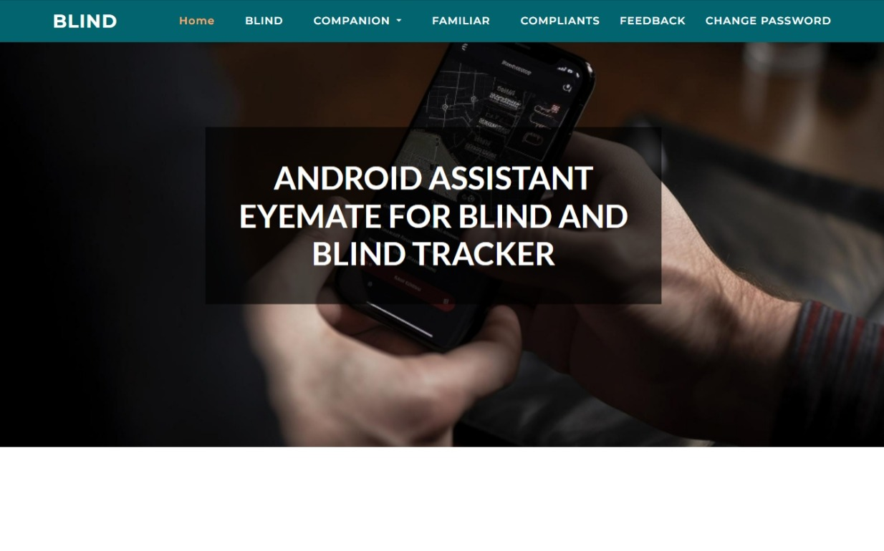



**ADMIN PAGE SHOTS:**

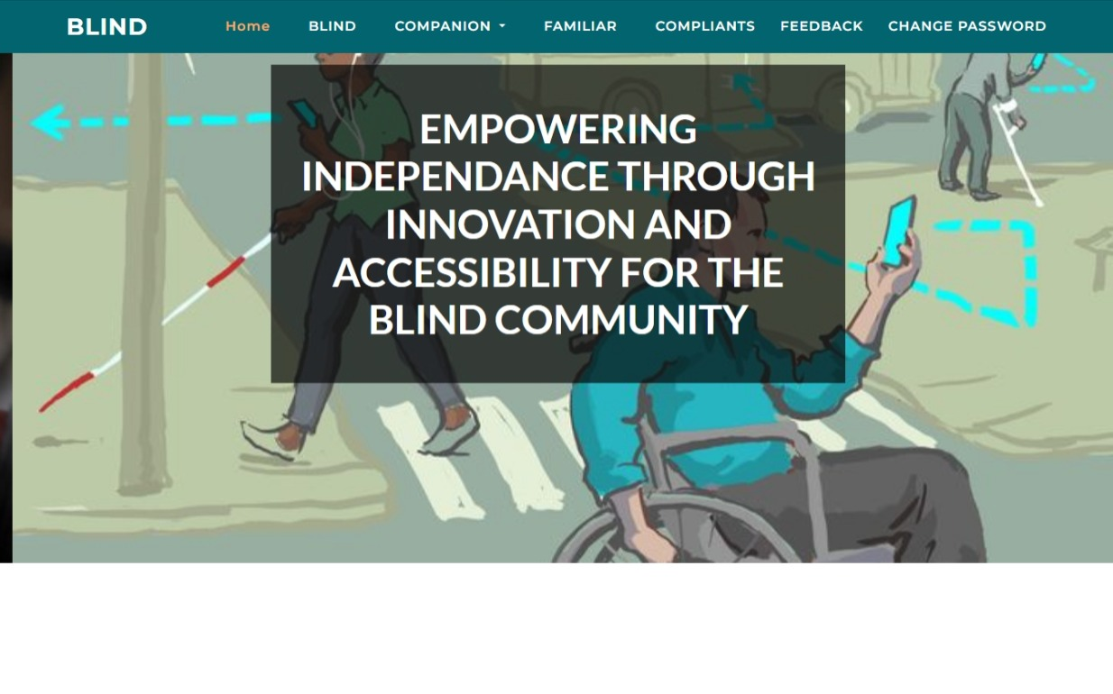

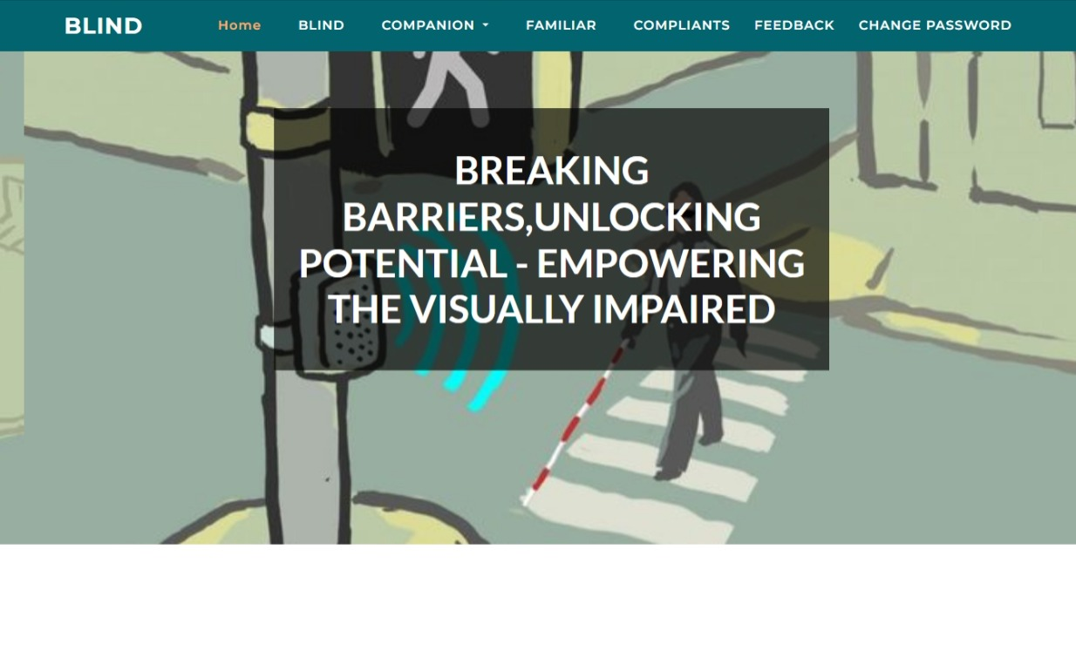



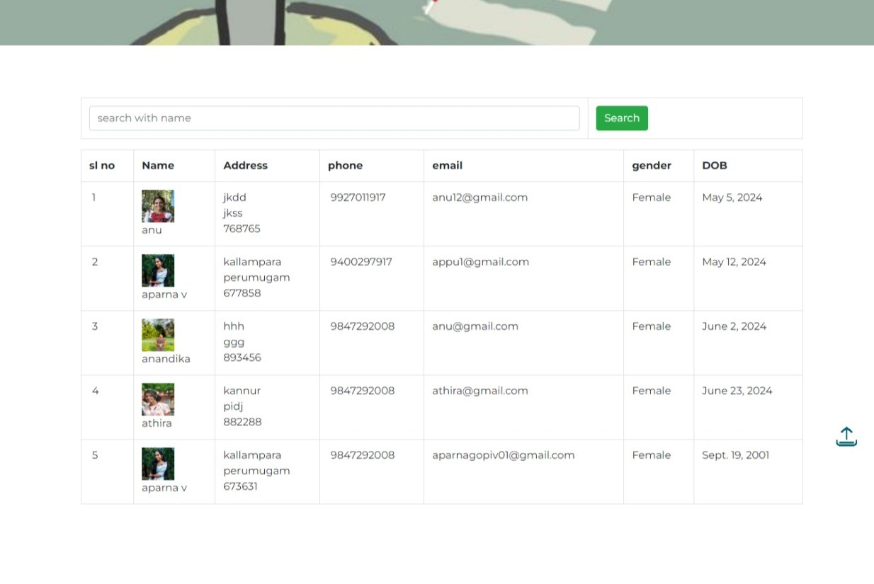

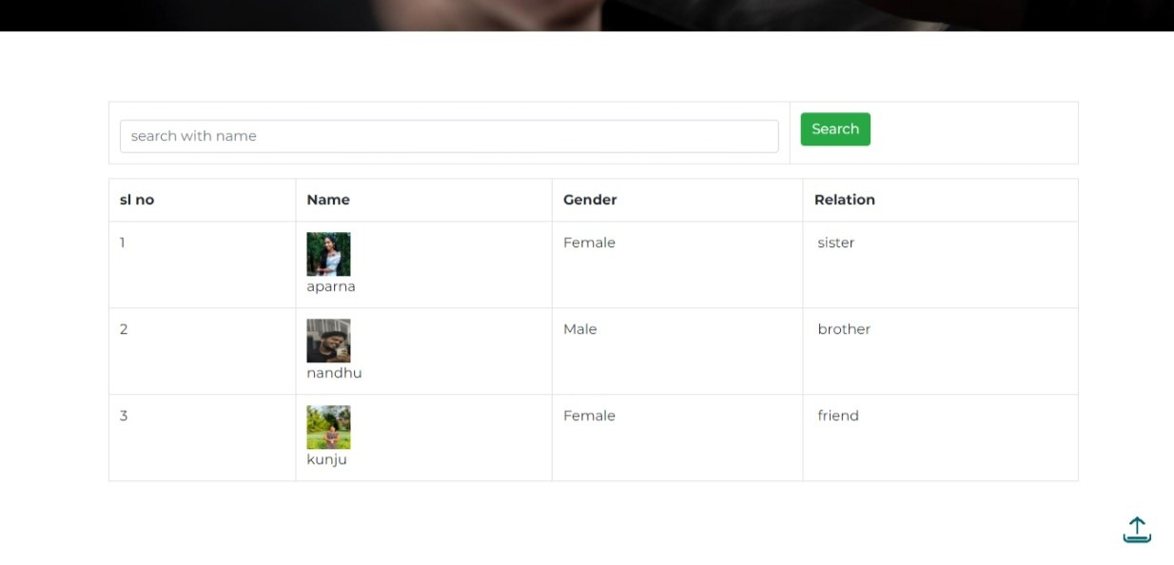

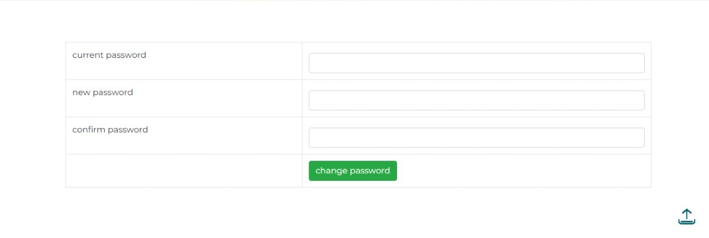

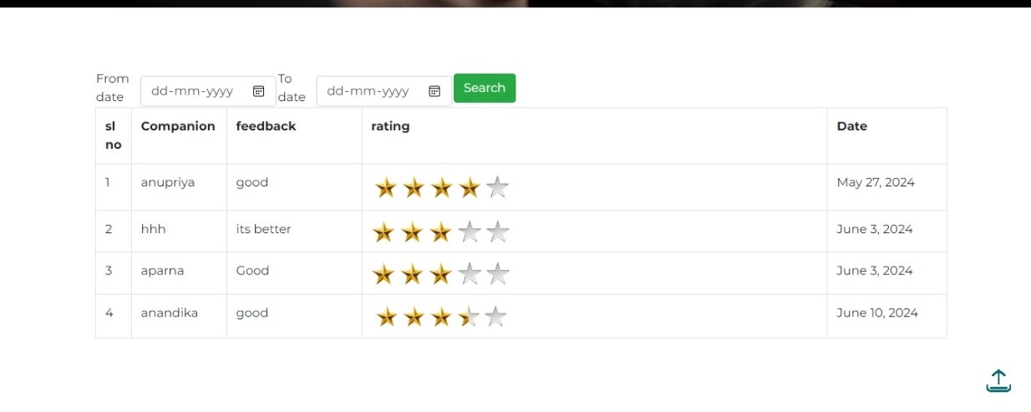

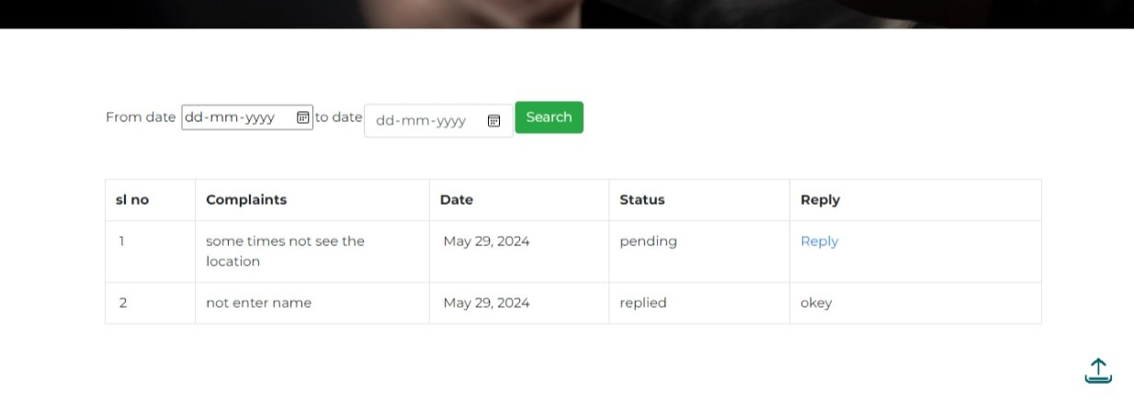

 **COMPANION PAGE:**

**SIGN UP PAGE**

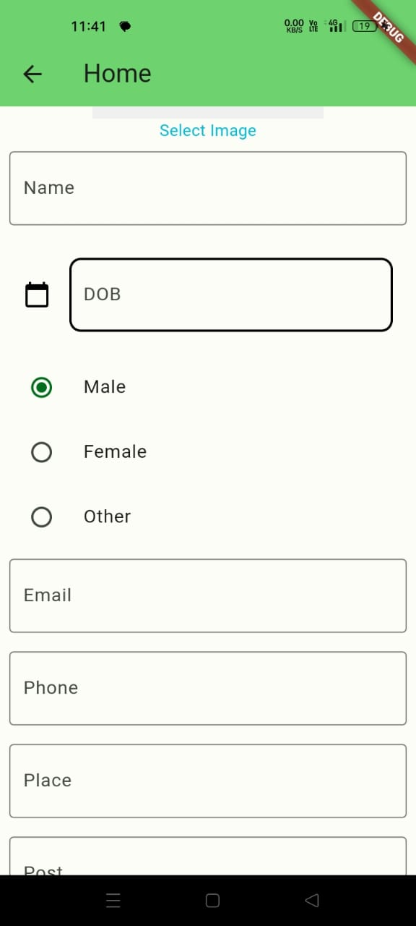 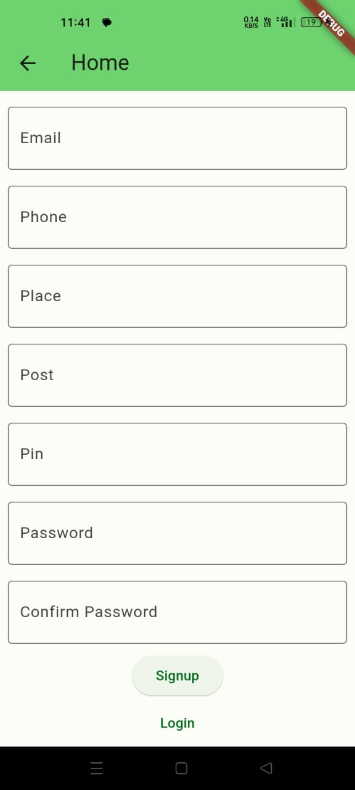

** LOGIN PAGE HOME PAGE** 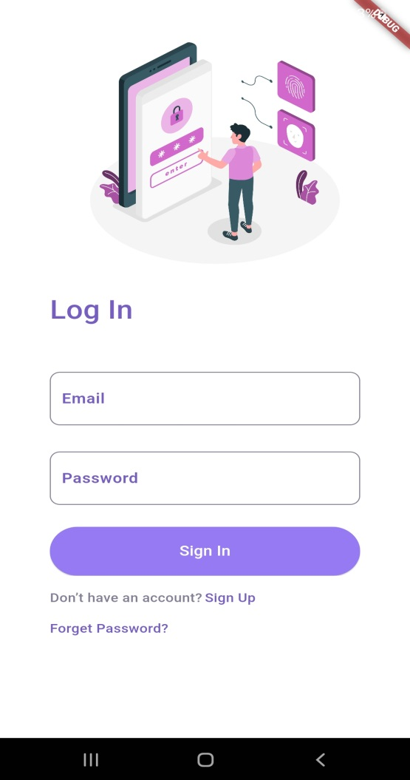 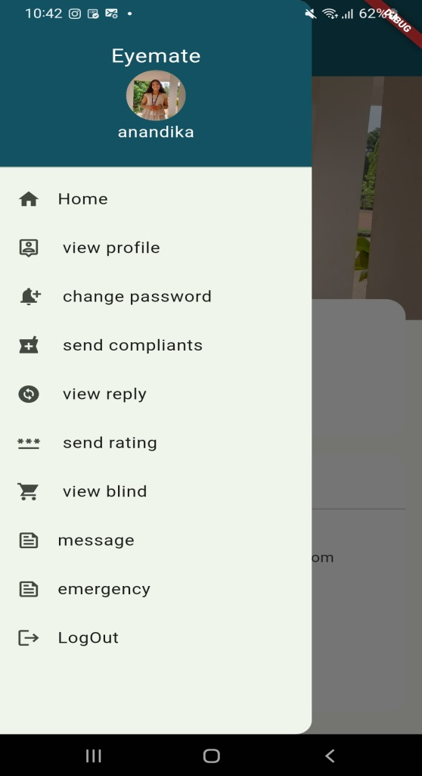

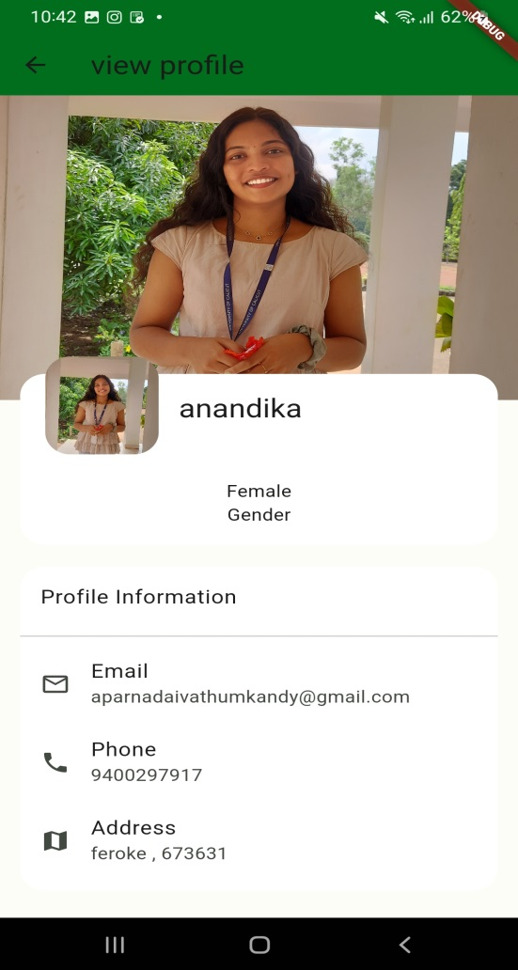 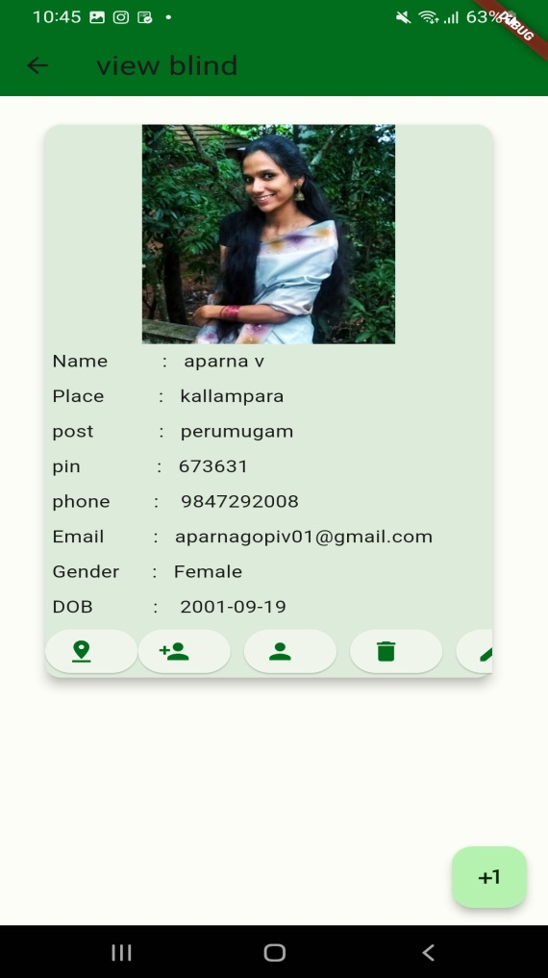

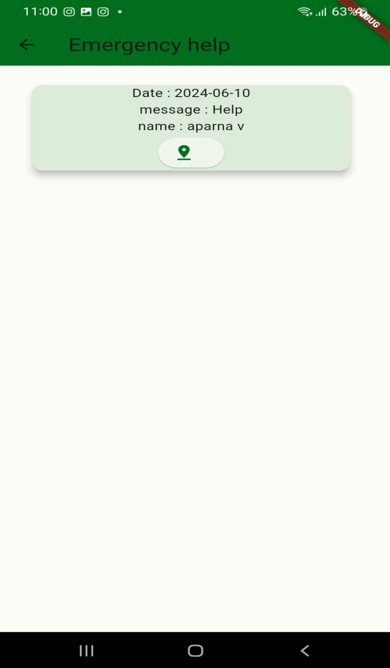 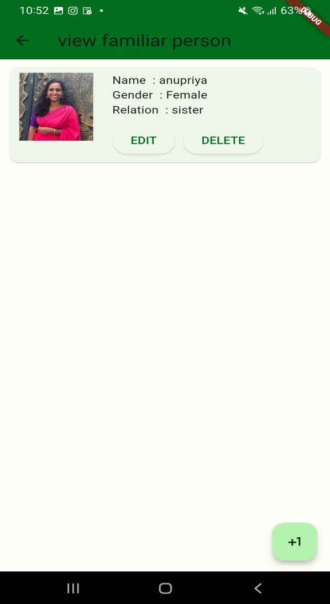 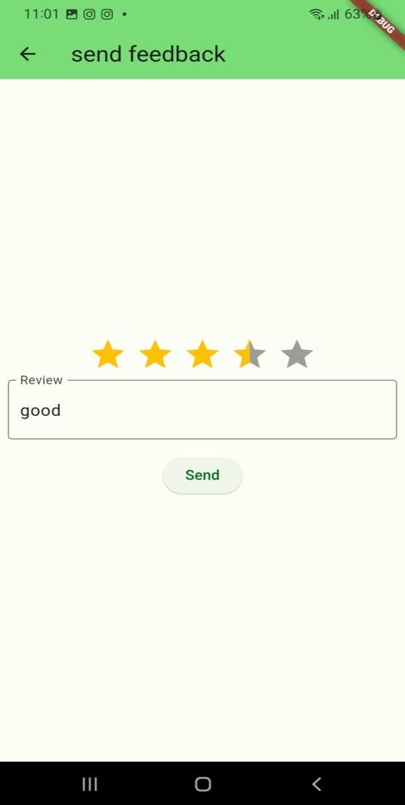 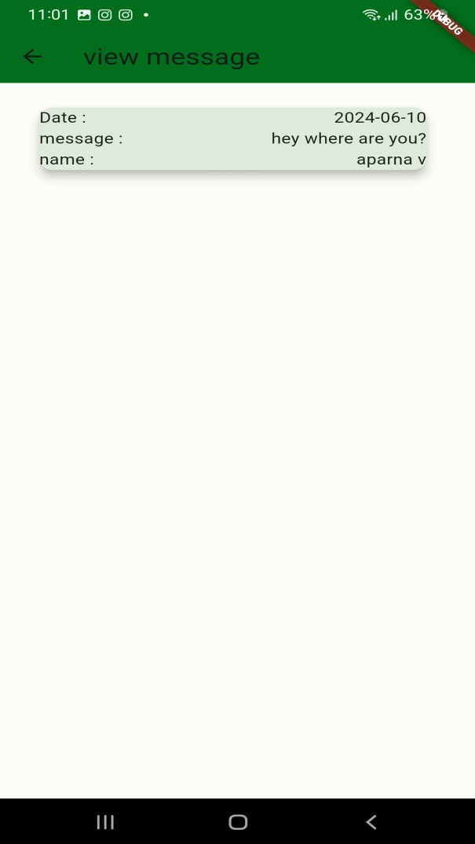



**BLIND APP SHOT**

